Our fourth day in Bath.

We went to Blaenavon to see the Big Pit Museum by bus, it was a long way. It was a guided tour in English, the guide explained why he had chosen this job, how workers had very difficult conditions to extract the coal in the pit without light.
He explained the difficulty of this job and he told us many stories about it.
So, it was a very interesting meeting and the best visit we had, because we wore a helmet with a flashlight like a miner.
Then, we understood that this work was only just for small people because inside, the pit is narrow.

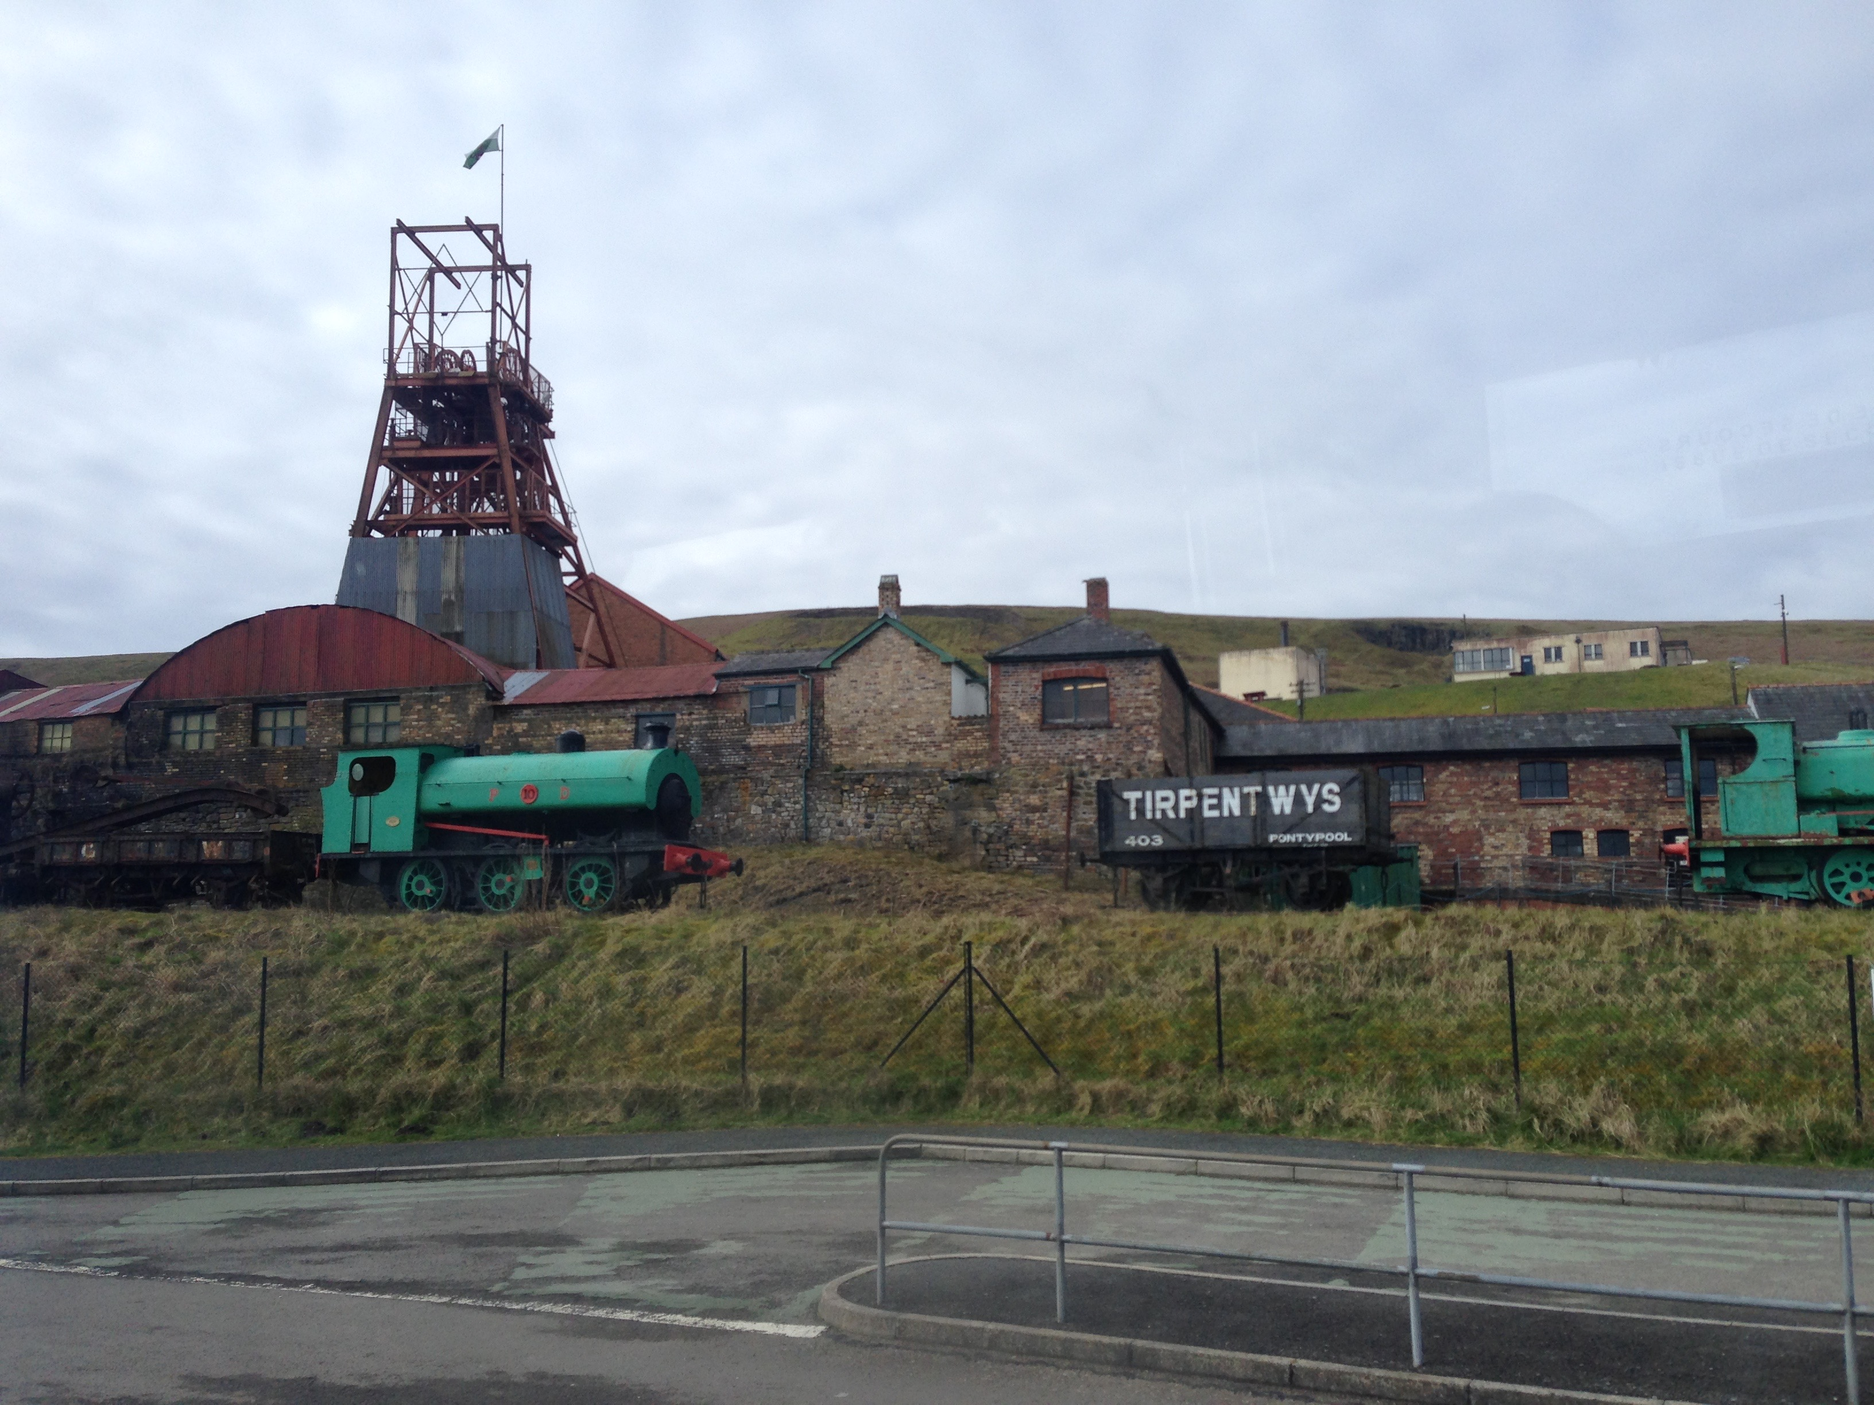
The Big Pit Museum.

In the afternoon, we went to visit the Clifton Suspension Bridge. When we arrived at this Bridge we were divided in 2 groups because there were 2 guides. They explained us the construction of this Bridge. It is one of the symbols of Bristol. In 1829 there was a competition to find the best designer to draw this bridge. Isambard kingdom Brunel won this competition and decided to draw a suspension bridge above the River Avon. There were many problems during the construction because, it was very expensive to build it and for a long time in England there had seen an economic crisis.
At the end, this bridge is 75m high and 412m long.

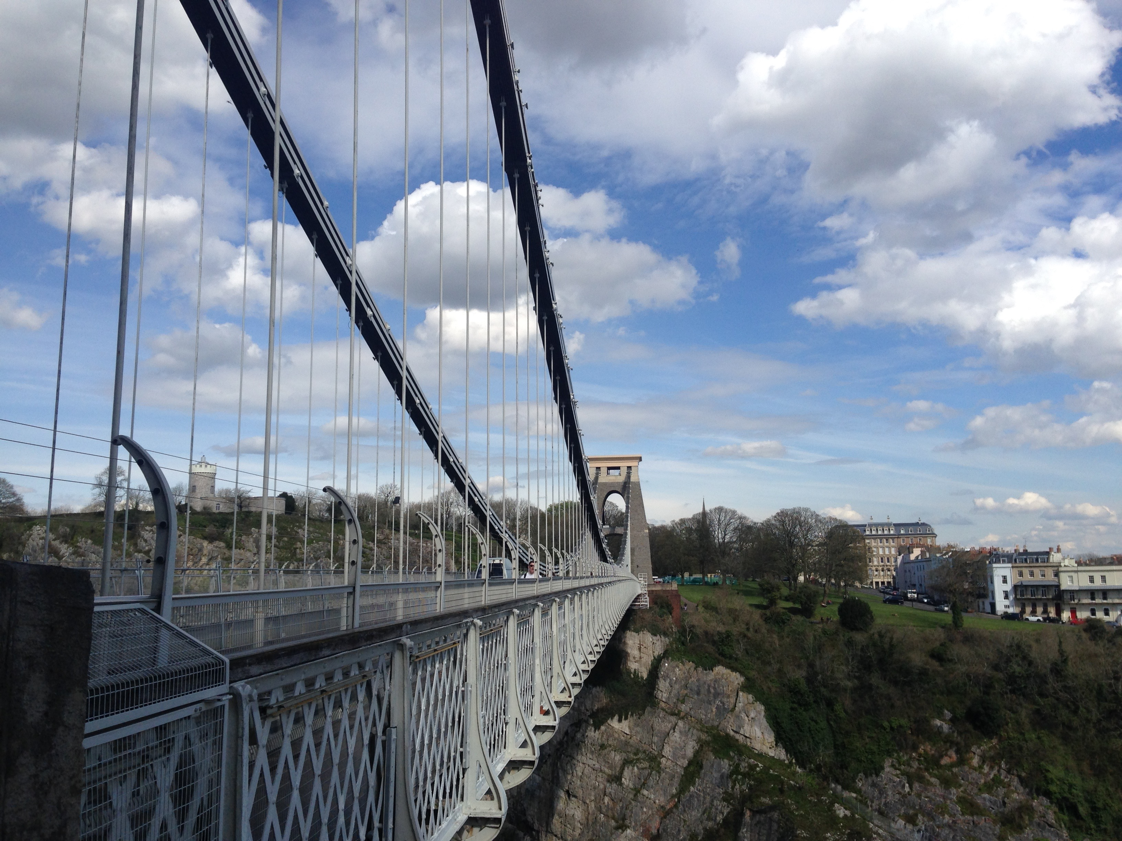
The Clifton Suspension Bridge.

Julie
Agathe
Solène

